**R Computer Lab #2**

**Question 1**

1. The hardest item was Item 10 which had the item difficulty of 0,529. Item 5 had the lowest item difficulty (-0,626) and is therefor the easiest item.

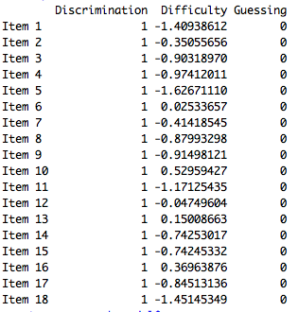

1. -1,63 ± 1,96 * 0,132 =

-1,63+1,96*0,132 = -1,36

-1,63-1,96*0,132 = -1,88

With 95% confidence we could say that the item difficulty for the easiest item, item 5, is between -1,88 and -1,36.

1. 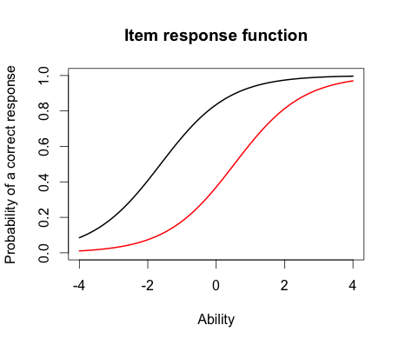
2. For the person with the ability of 0, that person has a probability of 0,2 of getting item 10 correct (red line), and a 0,8 probability of getting item 5 correct (black line).
3. The person who did the best of the test was number 49 and the score was 3,99. The person who did the worst on the test was number 393 and the score was -3,99.
4. 3,99 ± 1,96 * 2,20 =

3,99+1,96*2,20 = 8,30

3,99-1,96*2,20 = -0,32

With 95% confidence, the student who did best on the test had an ability estimate between -0,32 and 8,30.

**Question 2**

1. Items selected were items 1,10 and 15.
2. 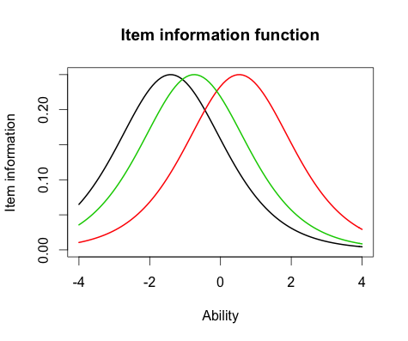
3. The item difficulty is different for all the items. All of the items have the same maximum item information (0,25).
4. 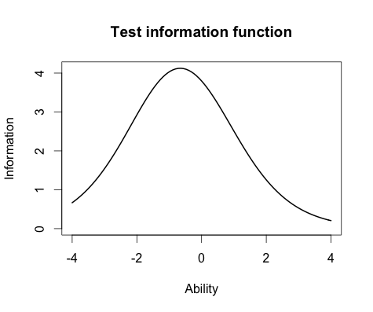
5. The majority of the information for this test is located around -0,8.

**Question 3**

1. Item 8 had the highest discriminator, which was 2,288. Item 12 had the lowest discriminator, which was 0,332.
2. No, the items that were the easiest and hardest in the Rasch model are not the same as in the 2-PL model. In the 2-PL model, the easiest item was item 1 which had the item difficulty of -2,00. The hardest item was item 10 with the item difficulty of 0,48.

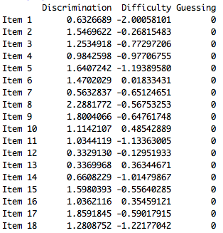

1. The correlation between the ability estimates on the Rasch model and the 2-PL was very strong (*r* = 0,97). Since the correlation is very close to 1,00 we could estimate that the person abilities from both models would be very similar.
2. 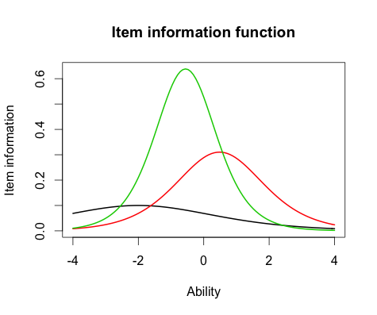
3. The items information are very different between items in the 2-PL model. For example the black line (item 1) does not discriminate well between students, compared to the red (item 10) and green line (item 15).The green line discriminates the best between students. The item information function differ from the models, because the 2-PL model takes discriminator into account and therefore the items information are diferent. In the Rasch model all the items have the same item information, because there is no discriminator in the model.

**Outputs :**

> rasch_model <- est(Scored, model="1PL", engine="ltm", rasch = TRUE)

> est_params <- rasch_model$est

> colnames(est_params) <- c("Discrimination", "Difficulty", "Guessing")

> rownames(est_params) <- paste("Item", 1:18)

> est_params

Discrimination Difficulty Guessing

Item 1 1 -1.40938612 0

Item 2 1 -0.35055656 0

Item 3 1 -0.90318970 0

Item 4 1 -0.97412011 0

Item 5 1 -1.62671110 0

Item 6 1 0.02533657 0

Item 7 1 -0.41418545 0

Item 8 1 -0.87993298 0

Item 9 1 -0.91498121 0

Item 10 1 0.52959427 0

Item 11 1 -1.17125435 0

Item 12 1 -0.04749604 0

Item 13 1 0.15008663 0

Item 14 1 -0.74253017 0

Item 15 1 -0.74245332 0

Item 16 1 0.36963876 0

Item 17 1 -0.84513136 0

Item 18 1 -1.45145349 0

> est_se <- rasch_model$se

> colnames(est_se) <- c("Discrimination SE", "Difficulty SE", "Guessing SE")

> rownames(est_se) <- paste("Item", 1:18)

> est_se

Discrimination SE Difficulty SE Guessing SE

Item 1 NA 0.1267448 0

Item 2 NA 0.1128011 0

Item 3 NA 0.1178581 0

Item 4 NA 0.1188426 0

Item 5 NA 0.1320051 0

Item 6 NA 0.1118476 0

Item 7 NA 0.1131572 0

Item 8 NA 0.1175527 0

Item 9 NA 0.1180162 0

Item 10 NA 0.1136598 0

Item 11 NA 0.1220123 0

Item 12 NA 0.1118797 0

Item 13 NA 0.1119630 0

Item 14 NA 0.1159197 0

Item 15 NA 0.1159189 0

Item 16 NA 0.1126941 0

Item 17 NA 0.1171115 0

Item 18 NA 0.1276902 0

> plot(irf(est_params[c(5,10),]), co = NA)

> est_abl <- as.data.frame(mlebme(Scored, ip = est_params))

> min(est_abl$est) # Prints the minimum score

[1] -3.999947

> max(est_abl$est) # Prints the maximum scores

[1] 3.999921

> which.min(est_abl$est) # Prints out the person minimum score

[1] 393

> which.max(est_abl$est) # Prints out the person with the maximum score

[1] 49

> est_abl[200,]

est sem n

200 -0.6390908 0.492458 18

> est_abl[393,]

est sem n

393 -3.999947 1.225286 18

> est_abl[49,]

est sem n

49 3.999921 2.204373 18

> 3,99+1,96*2,20

Error: unexpected ',' in "3,"

> 3.99+1.96*2.20

[1] 8.302

> plot(iif(est_params[c(1,10,15),]), co = NA)

> plot(tif(est_params))

> twopl_model <- est(Scored, model="2PL", engine="ltm")

> twopl_params <- twopl_model$est

> colnames(twopl_params) <- c("Discrimination", "Difficulty", "Guessing")

> rownames(twopl_params) <- paste("Item", 1:18)

> twopl_params

Discrimination Difficulty Guessing

Item 1 0.6326689 -2.00058101 0

Item 2 1.5469622 -0.26815483 0

Item 3 1.2534918 -0.77297206 0

Item 4 0.9842598 -0.97706755 0

Item 5 1.6407242 -1.19389580 0

Item 6 1.4702029 0.01833431 0

Item 7 0.5632837 -0.65124651 0

Item 8 2.2881772 -0.56753253 0

Item 9 1.8004066 -0.64761748 0

Item 10 1.1142107 0.48542889 0

Item 11 1.0344119 -1.13363005 0

Item 12 0.3329130 -0.12951933 0

Item 13 0.3369968 0.36344671 0

Item 14 0.6608229 -1.01479867 0

Item 15 1.5980393 -0.55640285 0

Item 16 1.0362116 0.35459121 0

Item 17 1.8591845 -0.59017915 0

Item 18 1.2808752 -1.22177042 0

> twopl_abl <- as.data.frame(mlebme(Scored, ip = twopl_params))

> cor(twopl_abl$est,est_abl$est)

[1] 0.9709497

> plot(iif(twopl_params[c(1,10,15),]), co = NA)